African Safari
Name: __________________________

Discover facts about ten of the most interesting African animals you encounter on your Virtual Safari. Make sure you watch movie clips, and listen to the animal sounds as well as sound clips about the animals. Describe in your own words what each animal looks like.
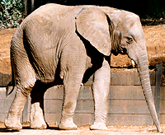

Name of Animal | Description
1.
2.
3.
4.
5.
6.
7.
8.
9.
10.

